MATHS WORKSHEET
GRADE-8
RATIONAL NUMBERS
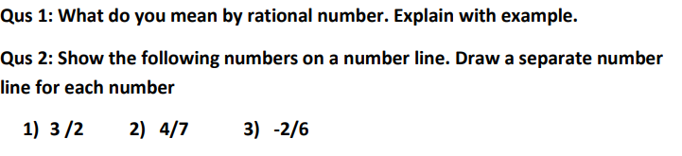
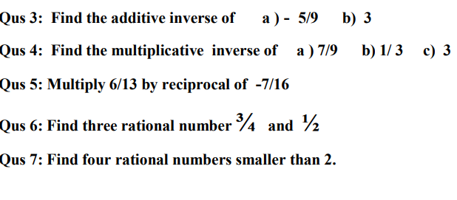
8. Solve:
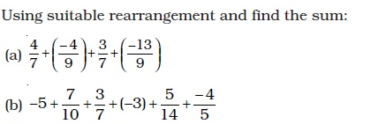

9.Solve:
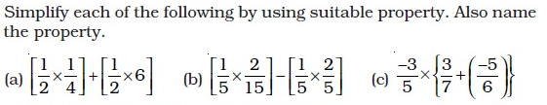

10.Solve:
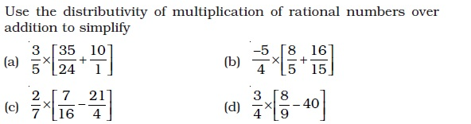
11.Solve

